***-🡪 Present in***  ***java.io.Serializable package***

***What is Serializiation?***

*Serialization in java is an important concept that deals with the* ***conversion of objects into a byte stream*** *to transport the java object from one JVM to the other is called as* ***serialization.***

*Byte stream is used to perform input and output operations of 8-bit bytes. 🡪 It processes data byte by byte*

*Character stream is used to perform input and output operations of 16-bit Unicode 🡪 It processes data character by character*

***Why do we need serialization?***

***Communication:-***

***Serialization involves the procedure of object*serialization*and*transmission This enables computer systems to share,design and execute objects simultaneously.**

-***Deep Copy:***

**Cloning*process is made simple by using Serialization. An exact*replica*of an object is obtained by serializing the object to a* byte array*, and then de-serializing it***

***Cross JVM Synchronization:***

***The major advantage of Serialization is that it works across different JVMs that might be running on different*architectures*or*Operating Systems.**

***How to Serialize an Object?***

* ***The class must implement the Serializable interface (a marker interface without methods).***
* ***Use ObjectOutputStream to write the object to an output stream.***

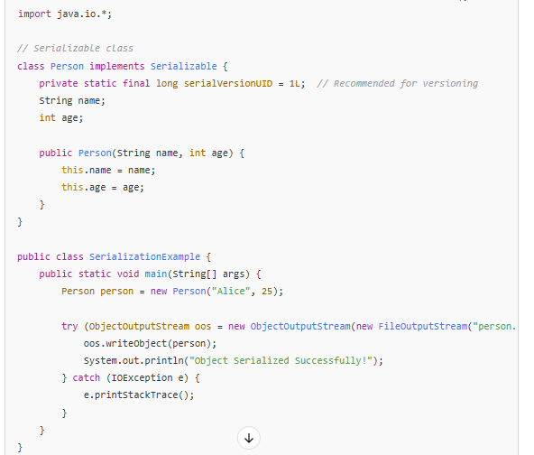

**What is deserialization ?**

*Deserialization is the process of reconstructing an object from a byte stream.*

*How to Deserialize an Object?*

* *Use ObjectInputStream to read the object from an input stream.*
* *The class must be present in the classpath.*

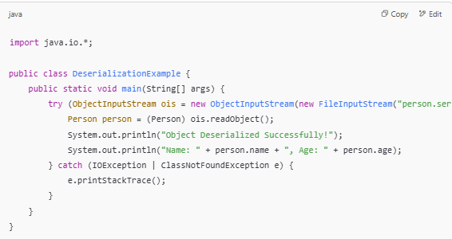

***Key Points***

* ***transient Keyword****: If a field is marked as transient, it will not be serialized.*
* ***serialVersionUID****: Used for version control of serialized classes.*
* ***Not all objects can be serialized****: Objects with non-serializable fields (like Thread, Socket) cannot be serialized.*

***Where is this Used in Real Life?***

1. ***Saving User Sessions*** *– Web applications store user sessions and retrieve them when a user logs back in.*
2. ***Caching Data*** *– Applications serialize objects to cache frequently used data to improve performance.*
3. ***Messaging Systems*** *– Serialized objects are sent over networks (e.g., in* ***Java RMI, Kafka, RabbitMQ****).*
4. ***Databases*** *– Some databases store Java objects as serialized blobs instead of traditional tables.*
5. ***Game Development*** *– Player progress and game state are serialized and stored.*

***Why is a transient Field Not Serialized in Java?***

*In Java, the transient keyword is used to indicate that a field should* ***not*** *be serialized when an object is converted into a byte stream. The main reason for this is to prevent serialization of sensitive, unnecessary, or non-serializable fields.*

***How Does transient Work?***

*When an object is serialized using ObjectOutputStream,* ***only non-transient fields*** *are included in the byte stream. During deserialization, transient fields are assigned their* ***default values*** *(e.g., null for objects, 0 for integers, false for booleans).*

***Reasons for Using transient***

1. ***Security Reasons***
   * *Fields like passwords, credit card numbers, or private keys should not be stored in a serialized file for security purposes.*
2. ***Non-Serializable Fields***
   * *Some fields (like Thread, Socket, or File) cannot be serialized because they represent runtime-dependent resources.*
3. ***Reducing Serialized File Size***
   * *If a field is temporary or can be derived later, it is not necessary to serialize it, reducing storage size.*

***Real-Life Applications***

1. *Sending object arrays over a network (e.g., chat applications, distributed systems).*
2. *Storing serialized data in files or databases.*
3. *Caching serialized objects to optimize performance.*

*🡪* ***Transient Keyword :-***

*The transient keyword in Java is used to indicate that a field* ***should not be serialized*** *when an object is converted into a byte stream.*

***Why Use transient?***

*Serialization is the process of converting an object into a byte stream so it can be saved to a file or transferred over a network. However, sometimes you* ***don’t want*** *certain fields to be serialized, such as:*

* *Sensitive information (e.g., passwords, security tokens).*
* *Temporary or calculated values that are regenerated at runtime.*
* *Non-serializable objects (e.g., objects that don’t implement Serializable).*

***How transient Works***

*When an object is serialized, all* ***non-transient*** *fields are saved. But* ***transient fields are skipped*** *and assigned their default values when the object is deserialized.*